Lack of confidence?

Effects of estimating sampling uncertainty to animal social network analysis

# Introduction

# Material and methods

## Simulations

In this paper, we focus on weighted (undirected) graphs, because the jump from binary to continuous quantification with weighted edges adds a more powerful framework when modeling biological systems (Barrat et al., 2004; Farine, 2014; Franks et al., 2010; Jacoby and Freeman, 2016; Kaiser-Bunbury and Blüthgen, 2015; Lusseau et al., 2009; Newman, 2004, 2006; Vázquez et al., 2005; Wey et al., 2008a). However, note that the methods used here can be easily extended to at least directed graphs, if not graphs with even more complex properties.

We considered a social group, studied through a constant method that record dyadic observations, without consideration for errors. We postulate that in this group, there is an individual characteristic that governs a node's probability of being observed in a dyad through this method. Therefore, a distribution of such individual probabilities can model an underlying phenomenon that shapes this group network. In practice, this could represent for instance the rank of an individual on a dominance-subordination scale, that can be positively associated with mounting occurrences in a sexual interaction network for instance (see for instance Cowlishaw and Dunbar, 1991), thus making high ranking individuals more probably observed in sexual dyads.

### Network generation

We generated three kinds of undirected and weighted networks following the process recapitulated in Figure 1, with different combinations of the number of nodes nid in the network and the number of dyadic observations nobs used to connect them. We randomly generated these lists of dyadic observations to mimic the process in which real-life scientists in ecology and evolution go from these observations to graphs that support their theoretical inferences. First, we generated 500 networks that serve as our ground truth, in the form of a distribution of networks that *could* have been observed given the underlying phenomenon (the distribution of individual probabilities) and simulation parameters. This first set provides the best representation we could empirically have from a "true", theoretical, social network we can never really know. Second, we generate one "observed" list of dyadic observations, simulating the collection of a study's data. Observed list from which we generate a single observed network. Lastly, we perform a dyadic bootstrap on the observed list to resample 500 "bootstrapped" dyadic observation lists, from which we obtain 500 bootstrapped networks.

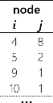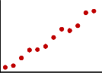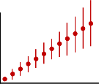

*x 500b*

*x 500c*

*Probability*

*node*

*node*

*Probability*

*x 5b*

*probability deviation x 5a*

Figure 1 simulated network generation process.

17 combinations of simulation parameters were chosen with (1) joint variation of both nid and nobs (nid/nobs = 50), (2) increasing of nid with a high and constant nobs = 50000, (3) increasing of nobs and constant intermediate nid = 50. a: A random deviation was added to each node probability of a given distribution and for a given set of parameters, inducing some individual variation around the distribution. b: From each of the 5 distributions on which deviation was applied, 500 ground truth lists were generated, as well as 5 single observed lists, referred to as trials. c: For each trial, a bootstrap is performed, generating 500 bootstrapped lists (c.f. main text and supplementary material).

A bootstrap is a resampling method where datapoints of a dataset are resampled with replacement. From the original dataset, a datapoint – in our case a dyadic observation – is randomly drawn, considering each datapoint equiprobable and independent. This process is repeated a number of time equal to the number of datapoints in the original dataset – in our case nobs times. This produce a bootstrapped resampled dataset of same size, likely to be close to the original, but with probable variations driven by the original data. Several hundred of these resampled datasets – in our case 500 bootstrapped lists – are generated, from which properties, statistics, etc., can be calculated, providing a distribution of probable values. Thus, such a bootstrap can provide a data-driven assessment of network measures uncertainty, through confidence intervals for instance, or provide whole distributions. Note that our method here consider a dyadic observation as one datapoint. Lusseau and colleagues (2009) and Farine and Strandburg-Peshkin (2015), who relied on comparable non-parametric bootstrap for uncertainty estimation, used animal clusters and sampling periods as their datapoints, respectively. This has to do with our case study ultimately relying on focal scan sampling (that produces sort of "egocentric" scans), whereas these previous studies involved group scan sampling (recording all associations happening in a group during one scan). Also, assuming independence of dyadic observations thus implies considering all observations as simultaneous, or at least losing the temporal scale.

We generated these 500 + 1 + 500 = 1001 networks with different combinations of parameters where: (1) the number of nodes nid and the number of observations nobs increased proportionally (with nobs = 50nid), (2) the number of nodes is fixed at an intermediate level (nid = 50 nodes) and with different magnitudes of number of observations (ranging from 50 to 10000), and (3) the number of observations is set at a high level (nobs = 50000) and the number of nodes varies (ranging from 10 to 500). For more details on the combination of parameters, see supplementary material X. Finally, we generated networks in experimental "blocks": for a set of parameters nid, nobs and a distribution, 5 random deviation from the distribution were made, each leading to 1 set of 500 ground truth networks. For each of these 5 "ground truth blocks", 5 single observed lists of observations were generated, each constituting a "trial block", and on each a bootstrap was performed. As a result, we generated networks for a nested empirical design with parameter combination block, ground truth block, and trials, nested in each other.

A total of 125 125 networks per parameter combination, for a total of 2 127 125 networks, were therefore generated as support for comparison.

### Network comparison

When comparing two networks together – an empirical network to a model one, etc. (Croft et al., 2011; Newman, 2018; Snijders, 2011) –, most studies evaluate how correlated derived network measures are. Here, as a proof of concept as well as fueling the question of network uncertainty with other types of argument, we wanted to estimate (dis)similarity between networks in a more direct fashion. Instead of relying on metrics that are extracted from the networks, we tried to consider networks whole objects of their own kind, or at least with object containing as much information.

To do so, we introduce here the concept of network distance. Distances, with their relations to norms, describe how close/related or distant/different two elements are, in a relevant space – here, a "network-space" or "matrix-space" (Martínez and Chavez, 2019; Shore and Lubin, 2015). Consider an undirected weighted network with n nodes. Indeed, while its (weighted) edge list's dimensions can be at most bounded without knowing its data (precisely, containing between 0 and n² - n pairs of nodes with their associated weights, twice as much if the network was directed), an adjacency matrix will have consistent dimensions, n x n, making Mn a relevant matrix-space. An adjacency matrix A of Mn has n rows and columns representing each node (Diestel, 2000). Its elements aij quantify the relationship between node i and j, aij being 0 if no relationship exists. Most social animal networks have elements aij belonging to R+, or {0,1} in the case of unweighted networks (Whitehead, 2008).

A network distance is, like between two numbers or to points in a 2D and 3D space, a single dimensioned value of R+ that increases when the two networks differ more (Martínez and Chavez, 2019). In this study we choose to represent a network by its adjacency matrix. Other properties intuitively hold true for distances in such a matrix-space: (i) the distance d(A,B) between adjacency matrices A and B of Mn is 0 if and only if A = B; (ii) d(A+B) ≤ d(A) + d(B) (the triangular inequality, with d(A) and d(B) being implicitly the distance to a zero-filled adjacency matrix); and (iii) d(αA) = |α|d(A).

We chose to use the Frobenius norm as a measure of distance between network adjacency matrices. It is defined as:

|  |  |
| --- | --- |
|  | Eq. 1 |

In our case of network comparison, the difference between two adjacency matrices will first be calculated and the Frobenius norm of the resulting matrix, trivially in Mn as well, correspond to our network distance. Thus, the distance between two networks with adjacency matrices A and B of Mn is:

|  |  |
| --- | --- |
|  | Eq. 2 |

which is symmetrical with respect to A and B. We relied on the Frobenius norm as it is a Euclidian distance – that can be viewed as a generalization of the Pythagorean theorem –, a simple yet relevant metric for network comparison as a study suggest (Martínez and Chavez, 2019).

We calculated network distances between: (i) ground truth networks and single observed networks (500 distances), (ii) ground truth networks and bootstrapped networks (500 distances). Because of computational limitations, we randomly selected 500 of the 250000 pairs of ground truth and bootstrapped networks, but otherwise all the distribution of distances could be obtained. For each distance of (i) and (ii), (iii) an adaptation of Erdős–Rényi random network (where each dyad is equally probable), with same nid and nobs, was associated.

Finally, additionally to raw distances, we calculated goodness of fit measures, inspired by the one introduced by Shore and Lubin (2015), defined as follow:

|  |  |
| --- | --- |
|  | Eq. 3 |

with Aobserved, AGT and Arandom being the adjacency matrices of an empirical network (either the single observed or a bootstrap one), a ground truth, and an Erdős–Rényi random network, respectively. As with Shore and Lubin study, this measure is comparable to a regression coefficient R²: it increases toward and is bounded by 1 when the distance between Aobserved and AGT decreases relatively to Arandom and AGT, but note that it decreases without lower bound when the numerator increase relatively, and can even become negative when the distance between Aobserved and AGT is greater than between Arandom and AGT (*i.e.* when a random network is closer to ground truth than the empirical one).

### Statistical analysis

For each parameter combination, we built linear mixed models (LMMs) with our goodness of fit measure (GOF) as the dependent variable, the empirical method (single network *versus* bootstrap) as the predicting variable, and the ground truth and trial blocks as an intercept random effect model (the latter blocks nested in the formers).

Simulations were written in R (R Core Team, 2019), networks were using the *igraph* package (Csardi and Nepusz, 2006) and LMMs were built with *glmmTMB* (Brooks et al., 2017). The scripts used are available in supplementary material X.

## Dynamic network subsampling

There are two types of temporal network: time-ordered and time-aggregated (Blonder et al., 2012). The former record a network's edges start and end times, while the latter pool data as with static networks, but sub-samples them according to the time of collection. Therefore, time-aggregated networks are more directly comparable to their static counterparts, as well as simple to create (Farine and Whitehead, 2015). One can think of time-aggregated networks as temporal "snapshots", or "slices" (Farine, 2018; Silk et al., 2017).

Farine (2018) reviewed aspects relevant to the choice of static *versus* dynamic networks in a study design. For our case study, dynamic network analysis is crucial given the scope of a disease transmission, as well as seasonal behavioural changes expected in such a free-ranging primate species. One can assume for instance that association patterns might vary during the reproductive season, and so might dynamic social networks.

Previous studies investigated different aspects and methods of dynamic sampling (Darst et al., 2016; Gurarie et al., 2009; Psorakis et al., 2015; Silk et al., 2017), but its associated uncertainty is still poorly understood and is yet to investigate. We introduce here a method to assess part of the temporal sub-sampling uncertainty of dynamic networks.

Relying on such time-aggregated networks, and somehow comparable to the variable time-windows presented by Psorakis and colleagues (2015), we wrote an R algorithm we called Random Time-Window Shift (see supplementary material X and Figure 2). This algorithm assumes several key dates spread in time of a non-network related process, *e.g.* individual captures, samples collection (the poop in the diagram), but also arbitrary constant time interval, as well as temporally distributed observations (vertical arrows), from which dynamic networks will be build.

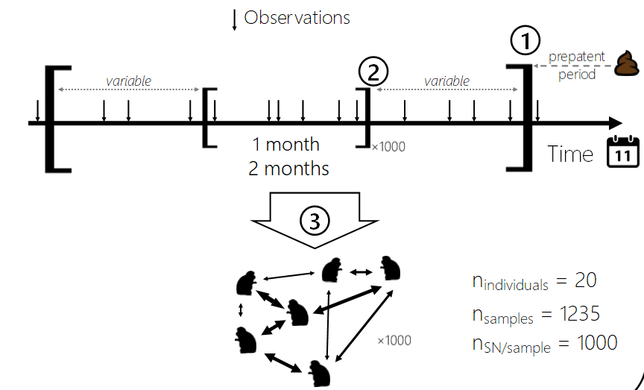

Figure 2 schematic of the process of the Random Time-Window Shift dynamic sub-sampling method

HERE MORE DETAILS

The duration of the large and small time-windows can be chosen in relevance of the biological process investigated, as well as the minimum number of observations to have included in the small time-window. Because random shifts of the small time-window within the large one are replicated many times (*e.g.* hundreds or thousands), we expect the method to incorporate a sense of uncertainty originating from the choice of sub-sampling for constructing time-aggregated networks. But our algorithm ensures that each networks contain at least the minimum number of observations defined by the user, as well as the minimum time to consider a snapshot robust enough. From the replicated shifts, a distribution of "shifted" networks properties or metrics can be generated. Confidence intervals for instance can then be computed to represent how uncertain a measure is according to the inclusion or not of "temporally neihbourging" datapoints. Here again, this method is data-driven, require no strong assumption and can be applied flexibly to varied datasets.

## Case study

Description of the Japanese macaque (*Macaca fuscata fuscata*) population of Kōshima can be found in Sarabian and MacIntosh (2015), Duboscq et al. (2016) and Romano et al. (2016). While we provide here a sufficient overview of the methods used during this case study, we invite the reader looking for more precision on the protocols employed to refer to MacIntosh et al. (2012, 2010) for the parasitological sampling, and Duboscq et al. (2016).

#### Study site and subjects

Data were collected intermittently and seasonally between September 2012 and November 2014 from a group of Japanese macaques (*Macaca fuscata fuscata*) inhabiting Kōshima islet, an uninhabited 0.32 km² island located ca. 300 m off the coast in Miyazaki prefecture, Kyūshū, Japan (31°27’6” N, 131°22’25” E). Two macaque groups inhabit the island but we focused on the ‘main group’, which has been provisioned since the 1950’s and for which life history, demographic and various socioecological data are available. Our analyses were based on data from 24 well-habituated and individually recognizable adult female macaques (range= 18 – 22 individuals depending on the season, all >7 years old) in the group, which consisted of *c.a.* 60 individuals in total across the study period. We focused on adult females because of their central roles in the matrilineal macaque societies (Thierry et al., 2004).

#### Parasitological data

Nematode infection was monitored via parasitological examination of concurrent fecal samples (N = 1050) for all study subjects, with a mean ± SD of 43.8 ± 17 per individual. Feces were collected immediately after defecation from identified subjects, before being stored and processed to determine the number of eggs per gram of fecal sediment (EPG), used as a measure of parasite abundance. We focused on 2 gastrointestinal nematode parasites with direct, i.e. fecal-oral, life cycles: *Oesophagostomum* *aculeatum* (*Strongylida*) and *Trichuris* sp. (*Trichurida*). Data on two other intestinal nematode species were excluded here because of a combination of long prepatent periods, indirect life cycles, data availability and relatively low prevalence in the host population, which precluded our ability to run the analyses presented. It should also be noted that a subset of individuals (N=12) were treated with a common anthelmintic drug (Stromectol® 3 mg; active compound: ivermectin) as part of an ongoing study relating parasite infection to fitness parameters (MacIntosh et al., unpublished data). We used this fact to relate social networks not only to general infection status across individuals, but also to investigate reinfection patterns among treated individuals.

#### Behavioural data

Behavioral data collection protocols for the data used here are described in Romano et al. (2016) and Duboscq et al. (2016). Briefly, we conducted 15-minute focal observations balanced across females and time of day (morning/afternoon), for a total of 1244 h of observation (15.6 ± 9.1 h per female) on 217 days across the study period. Every 5 minutes, a 10-meter proximity focal scan sample was collected to avoid potential biases induced by artificial resource enhancement, we excluded data collected during provisioning events. Dominance interactions were also collected (i.e. winners and losers of agonistic interactions) during focal observations and *ad libitum*. A total of 6422 proximity scans and 2805 agonistic interactions were recorded. Individual standardized Elo ratings were calculated using the *EloRating* package in R (Neumann et al., 2011), matching dominance interactions over the same periods as the social networks described below.

#### Social network analysis

Proximity data were used as our list of dyadic observations we refer to in the simulations we performed above, and were used to build adjacency matrices for each time-aggregated network. The a𝑖𝑗 elements of these adjacency matrices are the weights of the considered pair – the number of occurrences of the dyad in the observed list – controlled for sampling effort of both individual i and j, by dividing the raw weight with the sum of raw weight where either i or j is the focal of one dyadic observation. To gather which data to include in a network we applied our RTWS algorithm. In this case study, the minimal duration of the small time-window was set to 4 weeks within an 8-weeks large one, centered around the collection of a fecal sample (ref for justifications?), and minimum number of observations to 200 scans (ref idem). 500 random shifts were performed, applying optionally the dyadic bootstrap we introduce with the simulations. These proximity matrices were then used to build proximity networks using the *igraph* package in R (Csardi and Nepusz, 2006). For each network, each individual’s strength, degree and eigenvector centrality were determined using the same R package. These metrics were prioritized over others because of their plausible epidemiological relevance, following Borgatti’s (2005) classification of network flows (*e.g.* nematode infection would here follow “parallel duplications” and “walks” profiles as several individuals can be simultaneously infected from one source, and infection from individual A to B can be later transmitted again from B to A). Because of their inherent multicollinearity, although not always present in our dataset, we relied on a principal component analysis (PCA) to determine the best linear combination supporting the largest proportion of their variance after scaling. The first principal component (PC1) in either a one or two principal component(s) PCA explained consistently >70-80 % of the variation, where those social network centralities were all shown to be positively multicollinear. In other words, an increase in PC1 was associated with a collective increase in all 3 of these centrality measures, and can thus constitute a single summarized centrality dimension.

#### Uncertainty assessment

We set the parameters of our aggregating and processing algorithm to fit several experimental design considerations. Five designs were studied: (i) either seasonally time-aggregated networks and parasitological data (SAMPLE SIZE); (ii) similar to (i) but a dyadic bootstrap is performed on the seasonal networks; (iii) a more dynamic approach, with single small time-windows centered on fecal sample dates, minimum time of 4 weeks and and inclusion of at least the 200 observations (SAMPLE SIZE FOR T & O); (iv), similar to (iii) but applying the RTWS to generate 500 time-window shifts per fecal sample, with similar parameters and using a large time-windows of 8 weeks; and (v), similar to(iv) but applying a dyadic bootstrap (500 resamples) on the observations of each shifted time-window.

#### Statistical analysis

For each of these 5 designs, networks were built from which centrality measures (degree, strength and eigenvalues) were calculated and summarized into a single principal component, hereafter simply called centrality score, through a PCA.

GLMMs were performed with the number of egg per gram of feces (EPG) set as a dependent variable, the scaled centrality score, elo-score, age of the individual, treatment group/period considered (control group or if treated: before/after anthelmintic treatment) as fixed effect predictors, the individual nested in its matriline and the date of sample collection, nested in its month, nested in its season and in its year were set as random (intercept) effects. To account for zero inflation in our data, we built hurdle models in each sub-sampling design, where a first GLMM models sample infectious status as a binary dependent variable with previously mentioned predictors and random effects, using a binomial distribution family with a log-link function. The second model is built on samples with positive EPG, set as the dependent variable, using a negative binomial distribution family and a log-link function. VIFs (<1.2) were not showing any multicollinearity between the included predictors.

To compare model fit across the different data aggregation procedures, *ergo* on different datasets, we relied on R²GLMM for negative binomial GLMMs (Nakagawa Shinichi et al., 2017) of each full and best models, to ultimately see if one would model the overall phenomenon better.

For experimental approaches relying on multiple networks ((ii), (iv) and (v)), 500 GLMM were built for each of the 500 networks that had been generated. Confidence intervals of the model estimates, their p-values, and R²GLMM were then calculated across these multiple models.

For all models, Pearson residual plots were checked for heteroscedasticity and outliers, which were removed if necessary. Models were built using the *glmmTMB* package (Brooks et al., 2017), and more precisely their "nbinom2" family, "nbinom1" leading to model convergence issues with our datasets.

# Results

## Simulations

Coefficient of goodness of fit estimates are represented in Figure 4. As shown in table X (TO DO MORE COMPACT), performing a bootstrap on the observed dyads improved overall the goodness of fit compared to rely on a single network, with an average improvement of 4.4 % (range [-1%, 20%]). This is due to first, as shown in Figure 3, significantly smaller Frobenius norm from ground truth to bootstrapped networks than from ground truth to a single observed network, and second, to smaller distances to ground truth from either method than from random weighted graphs.

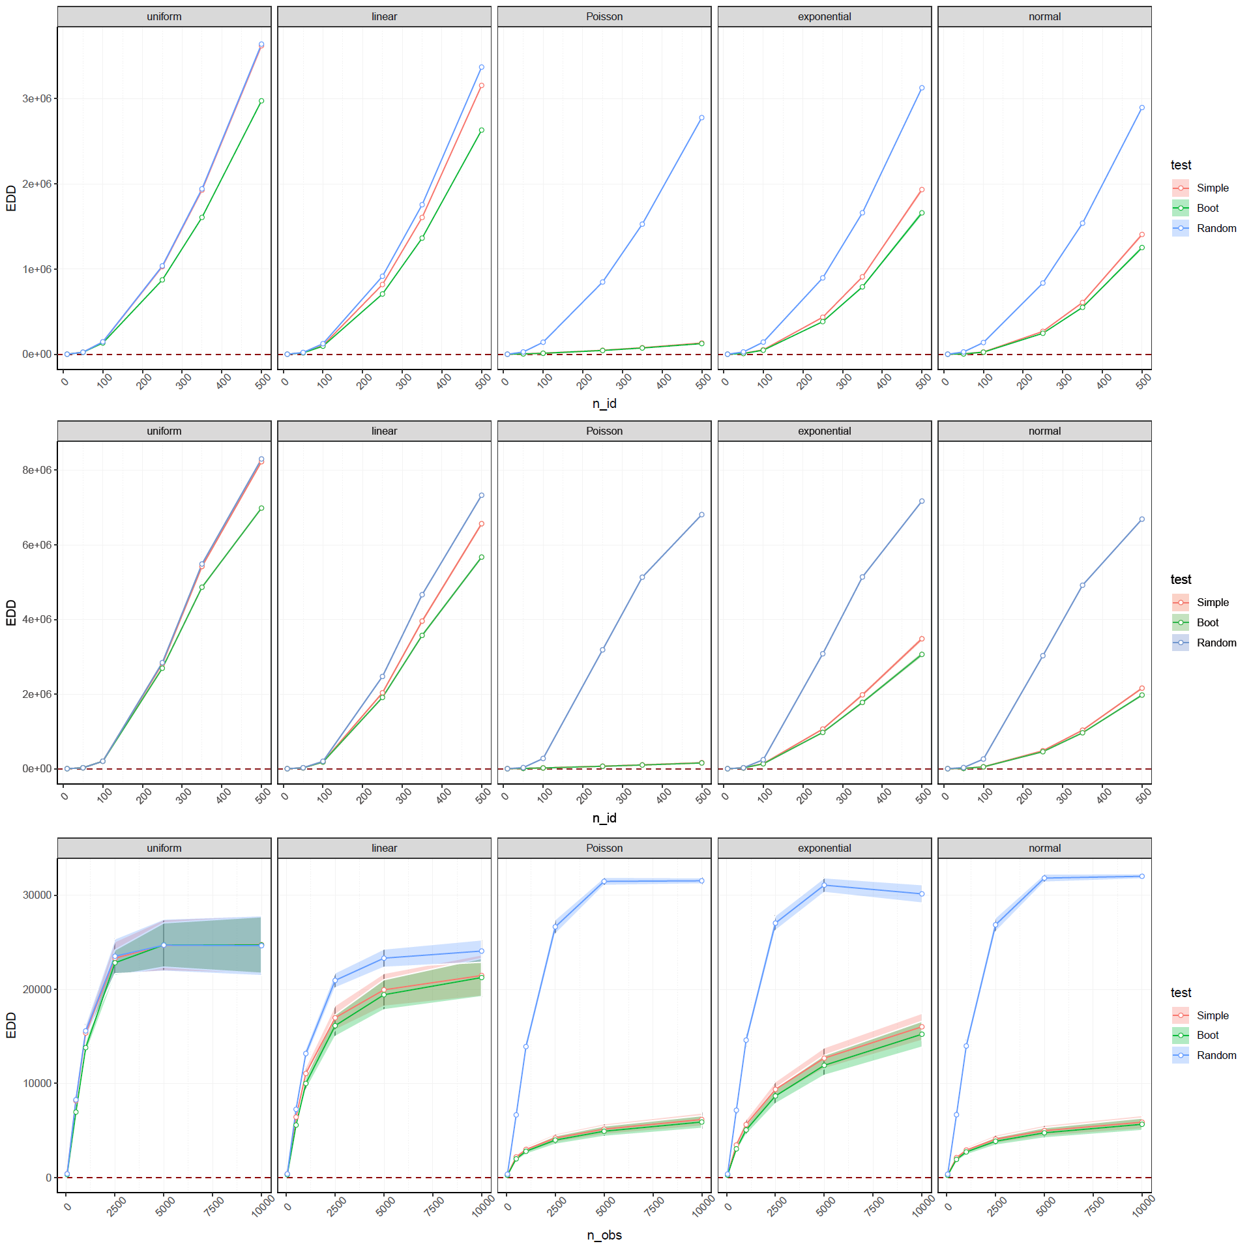

Figure 3 raw distances, 1st row nid and nobs increasing, 2nd row nobs constant, 3rd row nid constant

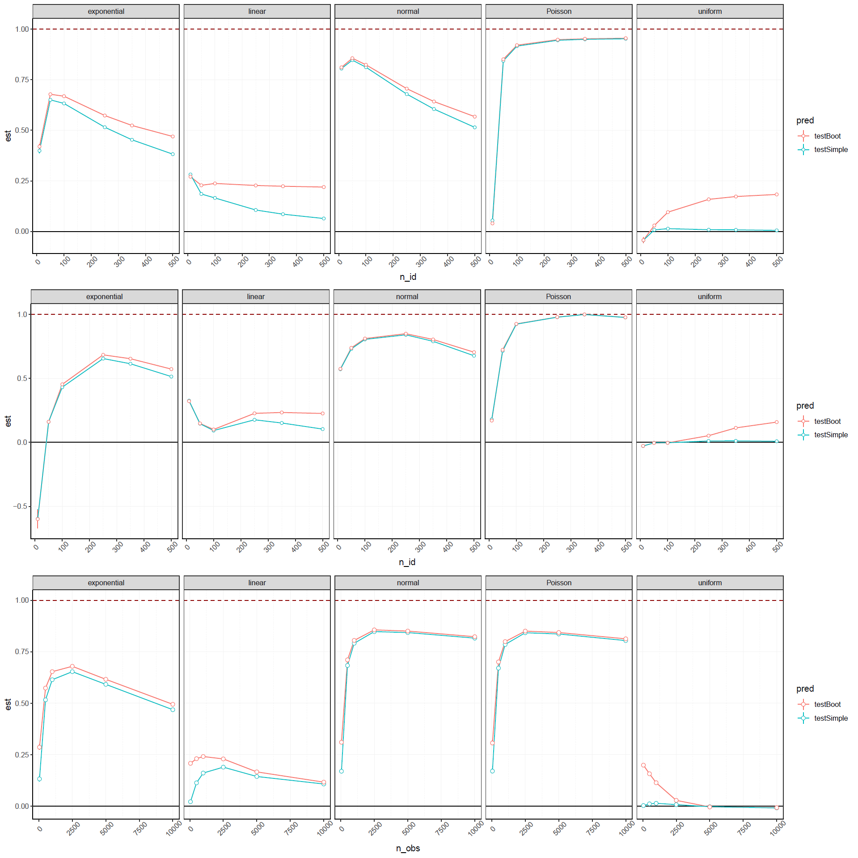

Figure 4 Goodness of fit 1st row nid and nobs increasing, 2nd row nobs constant, 3rd row nid constant

In details (Figure 5), difference in goodness of fit between both methods seemed to increase in favor of the bootstrap for increasing numbers of nodes (1st and 2nd lines). In comparison, the difference seemed to decrease with an increasing number of observations for a given number of nodes (3rd line). Bootstrap networks goodness of fit estimates were significantly higher (GLMM, p<0.001) except for cases with low number of nodes or high number of observations and constant number of nodes. NEED TO ADD LEGEND TO SMALLER GRAPH TO REFER TO THEM.

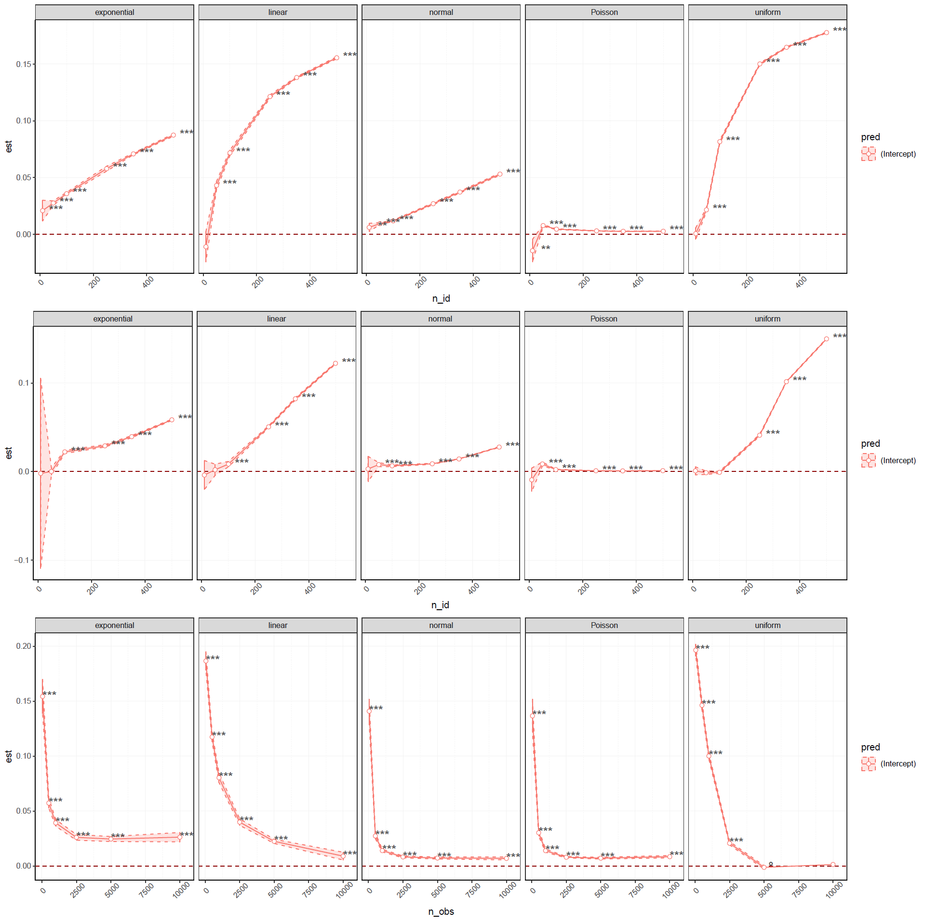

Figure 5 difference between estimates of goodness of fit (Boot - Simple), 1st row nid and nobs increasing, 2nd row nobs constant, 3rd row nid constant

## Case study

overall similar, trends of centrality linked to parasite load

but according to combination of implementations, slight differences

# Discussion

We showed that ultimate results of animal social network analysis can differ according to how uncertainty is incorporated in the methods, in both a controlled simulation framework and a field-based case study.

From simulations we showed that applying a dyadic bootstrap to evaluate a network sampling uncertainty – *i.e.* only from pure stochasticity during the acquisition of an "observed list" – leads to bootstrapped networks overall closer to ground truth, compared to only relying on a single observed network as if it was absolutely precise. We believe that, similarly, such an improvement can happen in our case study, or most empirical studies. Indeed, it should at worst lead to more conservative assumptions (but see Farine and Strandburg-Peshkin, 2015, for nuances in the case of  very small sub-sampling), and at best should provide overall estimates closer to a hypothetical underlying true phenomenon when considering other uncertain variables (in our case, parasitological results for instance). Additionally, being able to know how variable our results are, is in its own regards an added benefit compared to not knowing at all, allowing at the same time for more detailed analysis or different approach (comparing two network structures for instance, with a distribution of values and not single ones). Also, it might be beneficial to investigate if such bootstrap methods like the one presented here and those of previous studies (Farine and Strandburg-Peshkin, 2015; Lusseau et al., 2009) differ in uncertainty estimates, because while they follow similar concepts, they do not resample similar types of data (dyads compared to sampling periods).

For the case study, we believed more variation could have been observed, in terms of ultimate inferences or of regression coefficients, especially since the sub-sampling of observational data could lead to quite different datasets according to the method involved. We don't know if such consistency across methods tested in the observed trends are due to a strong and consistent signal in the data, or that, in fact these methods do not induce much variation. We wonder if incorporating specific aspects of network uncertainty could lead to more contrasted end results, expecting models to fit reality better as study and analysis design is refined. One critical aspect of observation method and uncertainty though, in lights of the work of Davis et al. (2018), the scan sampling from focal observations is inferior in terms of network robustness compared to scans observing the whole group as it does not maximize as much the number of potential association. However, in our case it also allowed for the collection of other and more general data.

In this regard, several tools emerged with this idea of incorporating network uncertainty and since several years (Farine and Strandburg-Peshkin, 2015; Lusseau et al., 2009; Snijders and Borgatti, 1999), or even to provide even more complex network or more specialized metrics to be investigated (*e.g.* see Chen and Onnela, 2018; Franks et al., 2009; Fushing et al., 2014; Newman, 2018; Peixoto, 2018). It can be exciting to see advanced tools being developed in other fields from math to human social networks, through neural networks, although of course their effects or relevance is also yet to be determined (James et al., 2009). This was one of the reasons we introduced in this study the concept of network distance and goodness of fit, as we believe they are promising tools with many potential applications in animal social networks, way beyond the use we made of them here. Comparably to how different metrics can represent different scales, different distances that rely on different norms, can be a richer way to compare network as whole objects, and at different scales (*e.g.* Bao et al., 2018; Giuseppe et al., 2011; Hammond et al., 2013; Jurman et al., 2015, 2011; Shore and Lubin, 2015). Some of these studies measure distances over other representations of networks as well. With parallels to eigen-vectors being derived from Laplacian matrices, which provide a "spectral" depiction of a network, distances of different kind can be evaluated comparing Laplacian matrices of different networks. This was suggested by Shore and Lubin's work on a spectral goodness of fit (2015) that propose such a tool as a measure of similarity incorporating the information of different scales and complexity of the network.

Also, and back to the question of improving models of biological dynamic system such as infectious disease transmission by incorporating dynamic sampling uncertainty, there is also another wider application of our RTWS we want to suggest. We think that the issue of variable or poorly-defined time-lag could be a specific aspect to investigate, notably reflecting concept of incubation period – or prepatent period in the case of macro-parasites –, a delay before the adhesion to an idea in the case of information transmission, etc. Our dynamic sub-sampling proposed here with the RTWS could be used to incorporate the effects of an uncertain time-lag, on top of incorporating uncertainty from variable sub-sampling. Additionally, with the joint development of automated data acquisition methods, we believe it is important to have available efficient and reliable tools to process increasing amount of data with such algorithms. This can facilitate investigations of the consequences of fine variations from dynamic sampling by, for instance, changing parameters like the minimum number of observations or minimum time interval used to produce a network. Ultimately, such methods could be used to provide insights on social network dynamics at different temporal scales.

One thing to note is that, in the case study, our social network approach was fairly consistent across methods tested (*i.e.* always relying on focal scan sampling for proximity networks with a given association index and minimum time and observations), apart from sub-sampling and application of a dyadic bootstrap. The lack of important variations in the results of our case study could suggest that these choices of protocol design are more impactful overall. This is even more true considering it is from *these* choices that a system will be well or poorly represented by the ultimate network(s), and that observations sampled will or will not be representative (Singh et al., 2010; Whitehead, 2008). In comparison, our work here mostly questions the importance of considering one's measure and data as absolutely precise or not. And while caution has to be maintained as to if the uncertainty measure obtained by these methods is accurate (see Farine and Strandburg-Peshkin, 2015 for comparison of uncertainty accuracy compared to a more Bayesian approach), we believe that there is no reason not to provide them. As even a measure overestimating or underestimating a confidence level is still probably more realistic that considering network values as point estimates.

While this is what we and other advocate for (*e.g.* Farine and Strandburg-Peshkin, 2015; Lusseau et al., 2009; Perreault, 2010; Sundaresan et al., 2009), to our knowledge, only few tools are effectively available for such implementation in social network analysis, especially for ecology and evolution (Borgatti et al., 2002; Chen and Onnela, 2018; Chen et al., 2019b; Friedman et al., 2013; Gel et al., 2017; Newman, 2018; Snijders and Borgatti, 1999; Teixeira and Derudder, 2018). This was one of the motivations for this paper, and for investigating and relying on methods that "make the best out of one data", without additional requirement and with a data-driven framework. This is also an opportunity we take to provide an R package, <insert name here> that, although rudimentarily at the time of writing, include an implementation of a similar dyadic bootstrap as well as the RTWS dynamic sub-sampling algorithm we described. We hope that this could become the start of the development of a toolbox focused on network uncertainty that could provide an easy solution for any social network analyst to use.

# Conclusion

We presented several methods that can be used broadly in ecology and evolution to produce networks that estimate uncertainty from stochastic sampling, for both static and dynamic analyses. After conducting simulations that suggest, through network distances and goodness of fit, an improved depiction of ground truth networks when providing uncertainty estimates, we conducted a case study to test these methods in an empirical system. We observed variations and similarities that we discussed. These results once again stress the importance of sound and justified choice of methods, especially with the gradual advances in tools available for animal social network analysis. We also take this opportunity to provide an R package to apply the methods presented in this paper. Because of their data-driven nature and the applicability on current dataset with no additional requirement, we advocate the use and development of such methods.

# Acknowledgment

# References

Bao, D., You, K., Lin, L., 2018. Network Distance Based on Laplacian Flows on Graphs. arXiv:1810.02906 [cs, stat].

Barrat, A., Barthelemy, M., Pastor-Satorras, R., Vespignani, A., 2004. The architecture of complex weighted networks. Proceedings of the National Academy of Sciences 101, 3747–3752. https://doi.org/10.1073/pnas.0400087101

Blonder, B., Wey, T.W., Dornhaus, A., James, R., Sih, A., 2012. Temporal dynamics and network analysis: *Temporal dynamics and network analysis*. Methods in Ecology and Evolution 3, 958–972. https://doi.org/10.1111/j.2041-210X.2012.00236.x

Boccaletti, S., Latora, V., Moreno, Y., Chavez, M., Hwang, D., 2006. Complex networks: Structure and dynamics. Physics Reports 424, 175–308. https://doi.org/10.1016/j.physrep.2005.10.009

Borgatti, S.P., 2005. Centrality and network flow. Social Networks 27, 55–71. https://doi.org/10.1016/j.socnet.2004.11.008

Borgatti, S.P., Brass, D.J., Halgin, D.S., 2014. Social Network Research: Confusions, Criticisms, and Controversies, in: Brass, D.J., Labianca, G. (JOE), Mehra, A., Halgin, D.S., Borgatti, S.P. (Eds.), Research in the Sociology of Organizations. Emerald Group Publishing Limited, pp. 1–29. https://doi.org/10.1108/S0733-558X(2014)0000040001

Borgatti, S.P., Carley, K.M., Krackhardt, D., 2006. On the robustness of centrality measures under conditions of imperfect data. Social Networks 28, 124–136. https://doi.org/10.1016/j.socnet.2005.05.001

Borgatti, S.P., Everett, M.G., Freeman, L.C., 2002. Ucinet for Windows: Software for social network analysis.

Borsboom, D., 2017. A network theory of mental disorders. World Psychiatry 16, 5–13. https://doi.org/10.1002/wps.20375

Brent, L.J.N., Lehmann, J., Ramos-Fernández, G., 2011. Social network analysis in the study of nonhuman primates: A historical perspective. American Journal of Primatology 73, 720–730. https://doi.org/10.1002/ajp.20949

Brooks, M., E., Kristensen, K., Benthem, K., J. ,van, Magnusson, A., Berg, C., W., Nielsen, A., Skaug, H., J., Mächler, M., Bolker, B., M., 2017. glmmTMB Balances Speed and Flexibility Among Packages for Zero-inflated Generalized Linear Mixed Modeling. The R Journal 9, 378. https://doi.org/10.32614/RJ-2017-066

Chen, S., Onnela, J.-P., 2018. A Bootstrap Method for Goodness of Fit and Model Selection with a Single Observed Network. arXiv:1806.11220 [stat].

Chen, Y., Gel, Y., R., Lyubchich, V., Nezafati, K., 2019a. Snowboot: Bootstrap Methods for Network Inference. The R Journal 10, 95. https://doi.org/10.32614/RJ-2018-056

Chen, Y., Gel, Y., R., Lyubchich, V., Nezafati, K., 2019b. Snowboot: Bootstrap Methods for Network Inference. The R Journal 10, 95. https://doi.org/10.32614/RJ-2018-056

Cowlishaw, G., Dunbar, R.I.M., 1991. Dominance rank and mating success in male primates. Animal Behaviour 41, 1045–1056. https://doi.org/10.1016/S0003-3472(05)80642-6

Croft, D.P., Darden, S.K., Wey, T.W., 2016. Current directions in animal social networks. Current Opinion in Behavioral Sciences 12, 52–58. https://doi.org/10.1016/j.cobeha.2016.09.001

Croft, D.P., James, R., Krause, J., 2008. Exploring Animal Social Networks. Princeton University Press.

Croft, D.P., Madden, J.R., Franks, D.W., James, R., 2011. Hypothesis testing in animal social networks. Trends in Ecology & Evolution 26, 502–507. https://doi.org/10.1016/j.tree.2011.05.012

Csardi, G., Nepusz, T., 2006. The igraph software package for complex network research. InterJournal Complex Systems 1695, 1695.

Darst, R.K., Granell, C., Arenas, A., Gómez, S., Saramäki, J., Fortunato, S., 2016. Detection of timescales in evolving complex systems. Scientific Reports 6, 39713. https://doi.org/10.1038/srep39713

Davis, G.H., Crofoot, M.C., Farine, D.R., 2018. Estimating the robustness and uncertainty of animal social networks using different observational methods. Animal Behaviour 141, 29–44. https://doi.org/10.1016/j.anbehav.2018.04.012

de Silva, S., Wittemyer, G., 2012. A Comparison of Social Organization in Asian Elephants and African Savannah Elephants. Int J Primatol 33, 1125–1141. https://doi.org/10.1007/s10764-011-9564-1

Diestel, R., 2000. Graph theory. Springer-Verlag New York, Incorporated.

Duboscq, J., Romano, V., Sueur, C., MacIntosh, A.J.J., 2016. Network centrality and seasonality interact to predict lice load in a social primate. Sci Rep 6. https://doi.org/10.1038/srep22095

Farine Damien R., Aplin Lucy M., Sheldon Ben C., Hoppitt William, 2015. Interspecific social networks promote information transmission in wild songbirds. Proceedings of the Royal Society B: Biological Sciences 282, 20142804. https://doi.org/10.1098/rspb.2014.2804

Farine, D.R., 2018. When to choose dynamic vs. static social network analysis. J Anim Ecol 87, 128–138. https://doi.org/10.1111/1365-2656.12764

Farine, D.R., 2014. Measuring phenotypic assortment in animal social networks: weighted associations are more robust than binary edges. Animal Behaviour 89, 141–153. https://doi.org/10.1016/j.anbehav.2014.01.001

Farine, D.R., Strandburg-Peshkin, A., 2015. Estimating uncertainty and reliability of social network data using Bayesian inference. R. Soc. open sci. 2, 150367. https://doi.org/10.1098/rsos.150367

Farine, D.R., Whitehead, H., 2015. Constructing, conducting and interpreting animal social network analysis. J Anim Ecol 84, 1144–1163. https://doi.org/10.1111/1365-2656.12418

Feczko, E., Mitchell, T.A.J., Walum, H., Brooks, J.M., Heitz, T.R., Young, L.J., Parr, L.A., 2015. Establishing the reliability of rhesus macaque social network assessment from video observations. Animal Behaviour 107, 115–123. https://doi.org/10.1016/j.anbehav.2015.05.014

Franks, D.W., James, R., Noble, J., Ruxton, G.D., 2009. A foundation for developing a methodology for social network sampling. Behav Ecol Sociobiol 63, 1079–1088. https://doi.org/10.1007/s00265-009-0729-2

Franks, D.W., Ruxton, G.D., James, R., 2010. Sampling animal association networks with the gambit of the group. Behav Ecol Sociobiol 64, 493–503. https://doi.org/10.1007/s00265-009-0865-8

Friedman, N., Goldszmidt, M., Wyner, A., 2013. Data Analysis with Bayesian Networks: A Bootstrap Approach. arXiv:1301.6695 [cs, stat].

Fushing, H., Chen, C., Liu, S.-Y., Koehl, P., 2014. Bootstrapping on Undirected Binary Networks Via Statistical Mechanics. J Stat Phys 156, 823–842. https://doi.org/10.1007/s10955-014-1043-6

Gaichas, S.K., Francis, R.C., 2008. Network models for ecosystem-based fishery analysis: a review of concepts and application to the Gulf of Alaska marine food web. Can. J. Fish. Aquat. Sci. 65, 1965–1982. https://doi.org/10.1139/F08-104

Gebreyes, W.A., Dupouy-Camet, J., Newport, M.J., Oliveira, C.J.B., Schlesinger, L.S., Saif, Y.M., Kariuki, S., Saif, L.J., Saville, W., Wittum, T., Hoet, A., Quessy, S., Kazwala, R., Tekola, B., Shryock, T., Bisesi, M., Patchanee, P., Boonmar, S., King, L.J., 2014. The Global One Health Paradigm: Challenges and Opportunities for Tackling Infectious Diseases at the Human, Animal, and Environment Interface in Low-Resource Settings. PLOS Negl Trop Dis 8, e3257. https://doi.org/10.1371/journal.pntd.0003257

Gel, Y.R., Lyubchich, V., Ramirez Ramirez, L.L., 2017. Bootstrap quantification of estimation uncertainties in network degree distributions. Scientific Reports 7, 5807. https://doi.org/10.1038/s41598-017-05885-x

Giuseppe, J., Roberto, V., Cesare, F., 2011. An introduction to spectral distances in networks. Frontiers in Artificial Intelligence and Applications 227–234. https://doi.org/10.3233/978-1-60750-692-8-227

Grear, D.A., Luong, L.T., Hudson, P.J., 2013. Network transmission inference: Host behavior and parasite life cycle make social networks meaningful in disease ecology. Ecological Applications 23, 1906–1914. https://doi.org/10.1890/13-0907.1

Griffin, R.H., Nunn, C.L., 2012. Community structure and the spread of infectious disease in primate social networks. Evolutionary Ecology 26, 779–800.

Gurarie, E., Andrews, R.D., Laidre, K.L., 2009. A novel method for identifying behavioural changes in animal movement data. Ecology Letters 12, 395–408. https://doi.org/10.1111/j.1461-0248.2009.01293.x

Hammond, D.K., Gur, Y., Johnson, C.R., 2013. Graph diffusion distance: A difference measure for weighted graphs based on the graph Laplacian exponential kernel, in: 2013 IEEE Global Conference on Signal and Information Processing. Presented at the 2013 IEEE Global Conference on Signal and Information Processing (GlobalSIP), IEEE, Austin, TX, USA, pp. 419–422. https://doi.org/10.1109/GlobalSIP.2013.6736904

Ings, T.C., Montoya, J.M., Bascompte, J., Blüthgen, N., Brown, L., Dormann, C.F., Edwards, F., Figueroa, D., Jacob, U., Jones, J.I., Lauridsen, R.B., Ledger, M.E., Lewis, H.M., Olesen, J.M., Veen, F.J.F.V., Warren, P.H., Woodward, G., 2009. Review: Ecological networks – beyond food webs. Journal of Animal Ecology 78, 253–269. https://doi.org/10.1111/j.1365-2656.2008.01460.x

Jacoby, D.M.P., Freeman, R., 2016. Emerging Network-Based Tools in Movement Ecology. Trends in Ecology & Evolution 31, 301–314. https://doi.org/10.1016/j.tree.2016.01.011

James, R., Croft, D.P., Krause, J., 2009. Potential banana skins in animal social network analysis. Behav Ecol Sociobiol 63, 989–997. https://doi.org/10.1007/s00265-009-0742-5

Jones, T.B., Aplin, L.M., Devost, I., Morand-Ferron, J., 2017. Individual and ecological determinants of social information transmission in the wild. Animal Behaviour 129, 93–101. https://doi.org/10.1016/j.anbehav.2017.05.011

Jurman, G., Riccadonna, S., Visintainer, R., Furlanello, C., 2011. Biological network comparison via Ipsen-Mikhailov distance. arXiv:1109.0220 [q-bio].

Jurman, G., Visintainer, R., Filosi, M., Riccadonna, S., Furlanello, C., 2015. The HIM glocal metric and kernel for network comparison and classification, in: 2015 IEEE International Conference on Data Science and Advanced Analytics (DSAA). Presented at the 2015 IEEE International Conference on Data Science and Advanced Analytics (DSAA), IEEE, Campus des Cordeliers, Paris, France, pp. 1–10. https://doi.org/10.1109/DSAA.2015.7344816

Kaiser-Bunbury, C.N., Blüthgen, N., 2015. Integrating network ecology with applied conservation: a synthesis and guide to implementation. AoB PLANTS 7. https://doi.org/10.1093/aobpla/plv076

Kasper, C., Voelkl, B., 2009. A social network analysis of primate groups. Primates 50, 343–356. https://doi.org/10.1007/s10329-009-0153-2

Krause, J., Lusseau, D., James, R., 2009. Animal social networks: an introduction. Behav Ecol Sociobiol 63, 967–973. https://doi.org/10.1007/s00265-009-0747-0

Lusseau, D., Whitehead, H., Gero, S., 2009. Incorporating uncertainty into the study of animal social networks. arXiv:0903.1519 [physics, q-bio].

MacIntosh, A.J., Jacobs, A., Garcia, C., Shimizu, K., Mouri, K., Huffman, M.A., Hernandez, A.D., 2012. Monkeys in the middle: parasite transmission through the social network of a wild primate.

MacIntosh, A.J.J., Hernandez, A.D., Huffman, M.A., 2010. Host age, sex, and reproductive seasonality affect nematode parasitism in wild Japanese macaques. Primates 51, 353–364. https://doi.org/10.1007/s10329-010-0211-9

Makagon, M.M., McCowan, B., Mench, J.A., 2012. How can social network analysis contribute to social behavior research in applied ethology? Applied Animal Behaviour Science 138, 152–161. https://doi.org/10.1016/j.applanim.2012.02.003

Martínez, J.H., Chavez, M., 2019. Comparing complex networks: in defence of the simple. New J. Phys. 21, 013033. https://doi.org/10.1088/1367-2630/ab0065

Mason, O., Verwoerd, M., 2007. Graph theory and networks in Biology. IET Systems Biology 1, 89–119. https://doi.org/10.1049/iet-syb:20060038

May, R.M., Anderson, R.M., others, 1979. Population biology of infectious diseases: Part II. Nature 280, 455–461.

Menche, J., Sharma, A., Kitsak, M., Ghiassian, S.D., Vidal, M., Loscalzo, J., Barabási, A.-L., 2015. Uncovering disease-disease relationships through the incomplete interactome. Science 347, 1257601. https://doi.org/10.1126/science.1257601

Mourier, J., Vercelloni, J., Planes, S., 2012. Evidence of social communities in a spatially structured network of a free-ranging shark species. Animal Behaviour 83, 389–401. https://doi.org/10.1016/j.anbehav.2011.11.008

Nakagawa Shinichi, Johnson Paul C. D., Schielzeth Holger, 2017. The coefficient of determination R2 and intra-class correlation coefficient from generalized linear mixed-effects models revisited and expanded. Journal of The Royal Society Interface 14, 20170213. https://doi.org/10.1098/rsif.2017.0213

Neumann, C., Duboscq, J., Dubuc, C., Ginting, A., Irwan, A.M., Agil, M., Widdig, A., Engelhardt, A., 2011. Assessing dominance hierarchies: validation and advantages of progressive evaluation with Elo-rating. Animal Behaviour 82, 911–921. https://doi.org/10.1016/j.anbehav.2011.07.016

Newman, M.E.J., 2018. Estimating network structure from unreliable measurements. Physical Review E 98. https://doi.org/10.1103/PhysRevE.98.062321

Newman, M.E.J., 2006. Modularity and community structure in networks. Proceedings of the National Academy of Sciences 103, 8577–8582. https://doi.org/10.1073/pnas.0601602103

Newman, M.E.J., 2004. Analysis of weighted networks. Phys. Rev. E 70, 056131. https://doi.org/10.1103/PhysRevE.70.056131

Newman, M.E.J., Girvan, M., 2004. Finding and evaluating community structure in networks. Phys. Rev. E 69, 026113. https://doi.org/10.1103/PhysRevE.69.026113

Noble, J., Davy, S., Franks, D.W., 2004. Eﬀects of the topology of social networks on information transmission, in: From Animals to Animats 8: Proceedings of the Seventh [i.e. Eighth] International Conference on Simulation of Adaptive Behavior. MIT Press, p. 10.

Pavlopoulos, G.A., Secrier, M., Moschopoulos, C.N., Soldatos, T.G., Kossida, S., Aerts, J., Schneider, R., Bagos, P.G., 2011. Using graph theory to analyze biological networks. BioData Mining 4, 10. https://doi.org/10.1186/1756-0381-4-10

Pedersen, A.B., Jones, K.E., Nunn, C.L., Altizer, S., 2007. Infectious Diseases and Extinction Risk in Wild Mammals. Conservation Biology 21, 1269–1279. https://doi.org/10.1111/j.1523-1739.2007.00776.x

Peixoto, T.P., 2018. Reconstructing Networks with Unknown and Heterogeneous Errors. Phys. Rev. X 8, 041011. https://doi.org/10.1103/PhysRevX.8.041011

Perkins, S.E., Cagnacci, F., Stradiotto, A., Arnoldi, D., Hudson, P.J., 2015. Comparison of social networks derived from ecological data: implications for inferring infectious disease dynamics. Journal of Animal Ecology 1015–1022. https://doi.org/10.1111/j.1365-2656.2009.01557.x@10.1111/(ISSN)1365-2656.SocialNetworkAnalysis

Perreault, C., 2010. A note on reconstructing animal social networks from independent small-group observations. Animal Behaviour 80, 551–562. https://doi.org/10.1016/j.anbehav.2010.06.020

Prado, F., Sheih, A., West, J.D., Kerr, B., 2009. Coevolutionary cycling of host sociality and pathogen virulence in contact networks. Journal of Theoretical Biology 261, 561–569. https://doi.org/10.1016/j.jtbi.2009.08.022

Proulx, S., Promislow, D., Phillips, P., 2005. Network thinking in ecology and evolution. Trends in Ecology & Evolution 20, 345–353. https://doi.org/10.1016/j.tree.2005.04.004

Psorakis, I., Voelkl, B., Garroway, C.J., Radersma, R., Aplin, L.M., Crates, R.A., Culina, A., Farine, D.R., Firth, J.A., Hinde, C.A., Kidd, L.R., Milligan, N.D., Roberts, S.J., Verhelst, B., Sheldon, B.C., 2015. Inferring social structure from temporal data. Behav Ecol Sociobiol 69, 857–866. https://doi.org/10.1007/s00265-015-1906-0

R Core Team, 2019. R: A Language and Environment for Statistical Computing. R Foundation for Statistical Computing, Vienna, Austria.

Romano, V., Duboscq, J., Sarabian, C., Thomas, E., Sueur, C., MacIntosh, A.J.J., 2016. Modeling infection transmission in primate networks to predict centrality-based risk: Individual Centrality and Infection Flow. Am. J. Primatol. 78, 767–779. https://doi.org/10.1002/ajp.22542

Sah, P., Mann, J., Bansal, S., 2018. Disease implications of animal social network structure: A synthesis across social systems. J Anim Ecol 87, 546–558. https://doi.org/10.1111/1365-2656.12786

Sarabian, C., MacIntosh, A.J.J., 2015. Hygienic tendencies correlate with low geohelminth infection in free-ranging macaques. Biology Letters 11, 20150757. https://doi.org/10.1098/rsbl.2015.0757

Shinde, P., Jalan, S., 2015. A multilayer protein-protein interaction network analysis of different life stages in Caenorhabditis elegans. EPL 112, 58001. https://doi.org/10.1209/0295-5075/112/58001

Shore, J., Lubin, B., 2015. Spectral goodness of fit for network models. Social Networks 43, 16–27. https://doi.org/10.1016/j.socnet.2015.04.004

Silk, M.J., Croft, D.P., Delahay, R.J., Hodgson, D.J., Boots, M., Weber, N., McDonald, R.A., 2017. Using Social Network Measures in Wildlife Disease Ecology, Epidemiology, and Management. BioScience 67, 245–257. https://doi.org/10.1093/biosci/biw175

Singh, L., Bienenstock, E.J., Mann, J., 2010. Perspectives on Social Network Analysis for Observational Scientific Data, in: Furht, B. (Ed.), Handbook of Social Network Technologies and Applications. Springer US, Boston, MA, pp. 147–168. https://doi.org/10.1007/978-1-4419-7142-5_7

Smith, K.F., Sax, D.F., Lafferty, K.D., 2006. Evidence for the Role of Infectious Disease in Species Extinction and Endangerment. Conservation Biology 20, 1349–1357. https://doi.org/10.1111/j.1523-1739.2006.00524.x

Snijders, L., Blumstein, D.T., Stanley, C.R., Franks, D.W., 2017. Animal Social Network Theory Can Help Wildlife Conservation. Trends in Ecology & Evolution 32, 567–577. https://doi.org/10.1016/j.tree.2017.05.005

Snijders, T.A., Borgatti, S.P., 1999. Non-parametric standard errors and tests for network statistics. Connections 22, 161–170.

Snijders, T.A.B., 2011. Statistical Models for Social Networks. Annu. Rev. Sociol. 37, 131–153. https://doi.org/10.1146/annurev.soc.012809.102709

Sueur, C., Jacobs, A., Amblard, F., Petit, O., King, A.J., 2011a. How can social network analysis improve the study of primate behavior? Am. J. Primatol. 73, 703–719. https://doi.org/10.1002/ajp.20915

Sueur, C., Petit, O., De Marco, A., Jacobs, A.T., Watanabe, K., Thierry, B., 2011b. A comparative network analysis of social style in macaques. Animal Behaviour 82, 845–852.

Sundaresan, S.R., Fischhoff, I.R., Dushoff, J., 2009. Avoiding spurious findings of nonrandom social structure in association data. Animal Behaviour 77, 1381–1385. https://doi.org/10.1016/j.anbehav.2009.01.021

Sundaresan, S.R., Fischhoff, I.R., Dushoff, J., Rubenstein, D.I., 2007. Network metrics reveal differences in social organization between two fission–fusion species, Grevy’s zebra and onager. Oecologia 151, 140–149. https://doi.org/10.1007/s00442-006-0553-6

Teixeira, F., Derudder, B., 2018. SKYNET: An R package for generating air passenger networks for urban studies. Urban Studies 0042098018803258. https://doi.org/10.1177/0042098018803258

Thierry, B., Singh, M., Kaumanns, W., 2004. Macaque societies: a model for the study of social organization. Cambridge University Press.

Thomas, A., Cannings, R., Monk, N.A.M., Cannings, C., 2003. On the structure of protein–protein interaction networks. Biochm. Soc. Trans. 31, 1491–1496. https://doi.org/10.1042/bst0311491

Vázquez, D.P., Morris, W.F., Jordano, P., 2005. Interaction frequency as a surrogate for the total effect of animal mutualists on plants. Ecology Letters 8, 1088–1094. https://doi.org/10.1111/j.1461-0248.2005.00810.x

Wey, T., Blumstein, D.T., Shen, W., Jordán, F., 2008a. Social network analysis of animal behaviour: a promising tool for the study of sociality. Animal Behaviour 75, 333–344. https://doi.org/10.1016/j.anbehav.2007.06.020

Wey, T., Blumstein, D.T., Shen, W., Jordán, F., 2008b. Social network analysis of animal behaviour: a promising tool for the study of sociality. Animal Behaviour 75, 333–344. https://doi.org/10.1016/j.anbehav.2007.06.020

Whitehead, H., 2008. Analyzing animal societies: quantitative methods for vertebrate social analysis. University of Chicago Press.

WHO, 2016. GHO: Causes of death [WWW Document]. WHO. URL http://apps.who.int/gho/data/node.main.GHECOD?lang=en (accessed 5.30.16).

Zengler, K., Zaramela, L.S., 2018. The social network of microorganisms — how auxotrophies shape complex communities. Nat Rev Microbiol 16, 383–390. https://doi.org/10.1038/s41579-018-0004-5